**Smart India Hackathon 2022**

**Product/Idea**

* What is the problem you are trying to solve?

In the current status quo, traditional text-based password authentication mechanism is the most popular on web but this mechanism is quite problematic. A good password needs to be “easy to remember and hard to guess” at the same time these easy to remember passwords are most vulnerable to cyber attacks.

As per a report on ComputerWorld, a network password cracker was run by a security team at a large company and within 30 seconds, they were able to identify about 80% of the passwords.

Studies also showed that since a user can only remember a limited amount of different passwords, they tend to use the same passwords for different accounts that means hacking into someone’s account on one platform can give access to his accounts on other platforms as well.

* How does your idea address the problem?

To counter the inherent problems with traditional textual authentication, we focus on developing a graphical user authentication which is nothing but utilizing images as passwords.

Psychological studies have shown that humans are capable of remembering pictures or images better than texts. Pictures and images are generally much easier to be remembered or recognized than that of textual objects. Hence this solution solves the problem of memorability encountered in traditional text based passwords to a certain extent.

Also graphical passwords are way more secure than textual passwords and it solves keystroke logging problems.

● Who are the target customers?

This project caters to all the people who use text based authentication system ranging from students to employees to everyone who signs up on the web. Since web is a household name these days and any website you visit requires you to sign up and provide your details hence our model can be employed at each of those places.

* What makes your idea unique?

It incorporates the idea of a wider and broader space for passwords and are not limited to alpha-numeric permutations. We would be using more playful and relatable images that help the user memorize and retain the password more easily and for a longer time giving them a safe browsing experience at the same time.

* Do you have a revenue generation model? If so please do share.

At this moment we do not have any revenue generation model, but at a later stage we plan to be in a service-based business model where we provide our login services to schools, colleges, banks, and all the big and renowned firms where login services are required thereby charging them for this service on a monthly subscription basis.

* What are the geographies, do you think the idea would be suitable for?

Our project is not necessarily suited for people belonging to a particular region or country, it is essentially useful for anyone accessing the web and signing up on any website or for any service all over the world.

* What are the risks associated with your idea and how can you mitigate it?

As of now the patterns and permutations of selecting the images is limited hence does not provides the user with a lot of choices. This can be problematic because if the project is used on a large scale, many people might end up selecting the same order of images and hence might have same password. We will mitigate this challenge by increasing the number of photos and introducing more categories to the kind of images the user can select. At a later stage we also plan to implement a method wherein the actual images selected also becomes important in addition to the order of images. This is to say the order and actual image both will be required to login.

* Who are the stakeholders involved in order to take bring this idea/product/service to the market?

National Cyber Coordination Centre, Cyber and Information Security (C&IS) Division(Ministry of Home Affairs)

**Intellectual Property Assessment**

* Is your idea patentable or patented?

The idea is not patentable since it is a platform designed using Django and MongoDb that serves as a better alternative to textual authentication.

* Is your idea built existing work? If so how is it different?

Yes the idea is an extension and an alternative to other authentication methods available in the market. Our service is different from the traditional methods available in the market. We provide more playful and relatable solution to the problem at hand. We provide an easy, more secure and easy to retain way of logging in to a platform. Our project incorporates the idea of a wider and broader space for passwords and is not limited to alpha-numeric permutations.

**Prototype/Proof of concept**

* What is the nature of the prototype/ proof of concept, you would be able to submit?

We will be providing the link to github repository.

Link :- https://github.com/Prateek692/Graphical-Password-Authentication

* Have you completed pilot tests for your prototype/POC? If so please share.

Our project is under the development phase only, we have tested and analysed the project in our team only and have not shifted beyond that scope till now. After making the UI of our project more user friendly and functional, we will test on a bunch of people ranging from age 5 to 70. Depending upon the response will add more features.

* What is the approximate cost of developing the prototype?

As of now the project is not completely developed so cost cannot be determined at this stage of time. Future cost depends upon the functionality user is asking for.

* Please share the relevant elements while submitting the POC/ Prototype

Block diagram

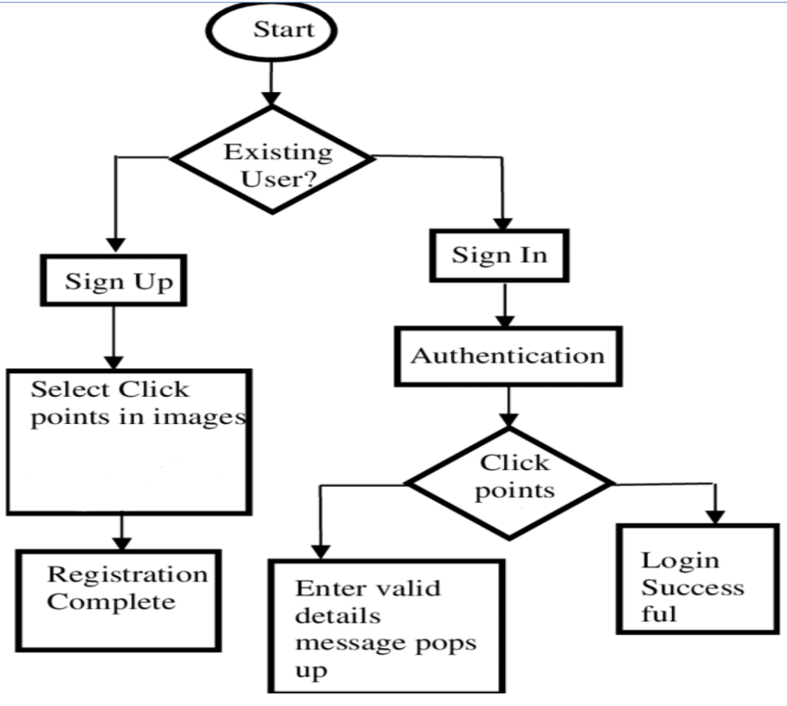

**Supporting details**

* What regulatory requirements have to be met to bring the idea to life?

Since our project deals with the login process, the security and authenticity of the system is of utmost importance so it needs to meet all the security regulations enforced by the Cyber and Information Security Division of Government Of India. New regulations, namely the Central Electricity Regulatory Commission (Indian Electricity Grid Code) Regulations 2020 have been proposed, which require all entities to have an information security policy in place to prevent unauthorised access and have necessary protection mechanisms such as firewalls.

* Do you have a business plan/ commercialization strategy? If so please share.

At this moment we do not have any revenue generation model, but at a later stage we plan to be in a service-based business model where we provide our login services to schools, colleges, banks, and all the big and renowned firms where login services are required thereby charging them for this service on a monthly subscription basis. We will also be providing extra features depending upon the clients requirement which will also lead to increased service charges.

* What is rough estimate of manufacturing/operational costs?

As of now the project is not completely developed so cost cannot be determined at this stage of time. Future cost depends upon the functionality user is asking for.

* What is volume of products/ amount of revenue do you expect to make in the first year?

Volume of products cannot be determined at this stage of time, as our project is still under development.